Paper Number 01

Drive train, IMPULSIFIERS

Mr. Dharmesh Nikhar

Mr. Vaibhav Khante

Mr. Akash Jain

Mr. Pratik Shivhare

Team Members, IMPULSIFIERS

Copyright © 2015 IMPULSIFIER

ABSTRACT

This paper is an introduction to the design, analysis of drive train of our vehicle for use in Student’s FORMULA SAE India. We have focused on analysis and mathematical calculations to get the optimum ways for better efficiency and effectiveness

INTRODUCTION

The Engine of KTM Duke 390 is designed for bike and our team is going to use the engine for our formula car. This gives difference in car performance, as weight of vehicle is increased. This paper briefly compares parameters of bike and car. The requirement of SUPRA car is that its power needed to be restricted by using venturi. It needs design of venturi so as to have proper working of engine with minimal losses. We have also sort out overheating problem due to sole use of water as a coolant. For that we have provided ducting to both radiator and muffler.

In electrical system we basically kept our focus on rulebook like following the requirements of different switches. We tried for innovation to make customer have awing experience of racing. It will enable drivers to detect the vehicles behind them within the range of 1.2m, thus helping driver to focus on race.

Main Section

**Engine specification:-**

* + Type -KTM DUKE 390 Engine -1cylinder, 4-stroke,Water cooled
  + Swept volume - 373.27cc
  + Maximum power - 44bhp @ 9500rpm
  + Maximum torque - 35Nm @ 7250rpm
  + Type of fuel used - Petrol
  + Compression ratio - 12.88 : 1
  + Bore - 89mm
  + Stroke - 60mm
  + Valves(per cylinder) - 4
  + Fuel System - Fuel Injection System
  + Ignition-Contactless, Controlled, Fully Electronic Ignition
  + Weight of Engine - 36kg
  + Rated acceleration - 3.96m/s2

As per the requirement of rulebook we have selected the engine of KTM. Its specifications are as given above

**Performance characteristics**

|  |  |  |
| --- | --- | --- |
| **Parameter** | **Bike** | **Car** |
| Weight (kgf) | 139 | 280 |
| Maximum speed(km/h) | 160 | 116 |
| `Rated acceleration (m/s2) | 3.96 | 1.8 |

**Intake Air Flow System**

The air will pass through these entire components. First it passes through a filter

Where the unwanted particle removes from air then it will pass through a throttle body, an injector is placed on a throttle body the amount of injection is control by a Electronic Control Module (ECM) The Mixture will pass through a Restrictor (Venturi Device) Throttle Diam. 20mm After restrictor it will enter in to the Cylinder through intake Manifold.

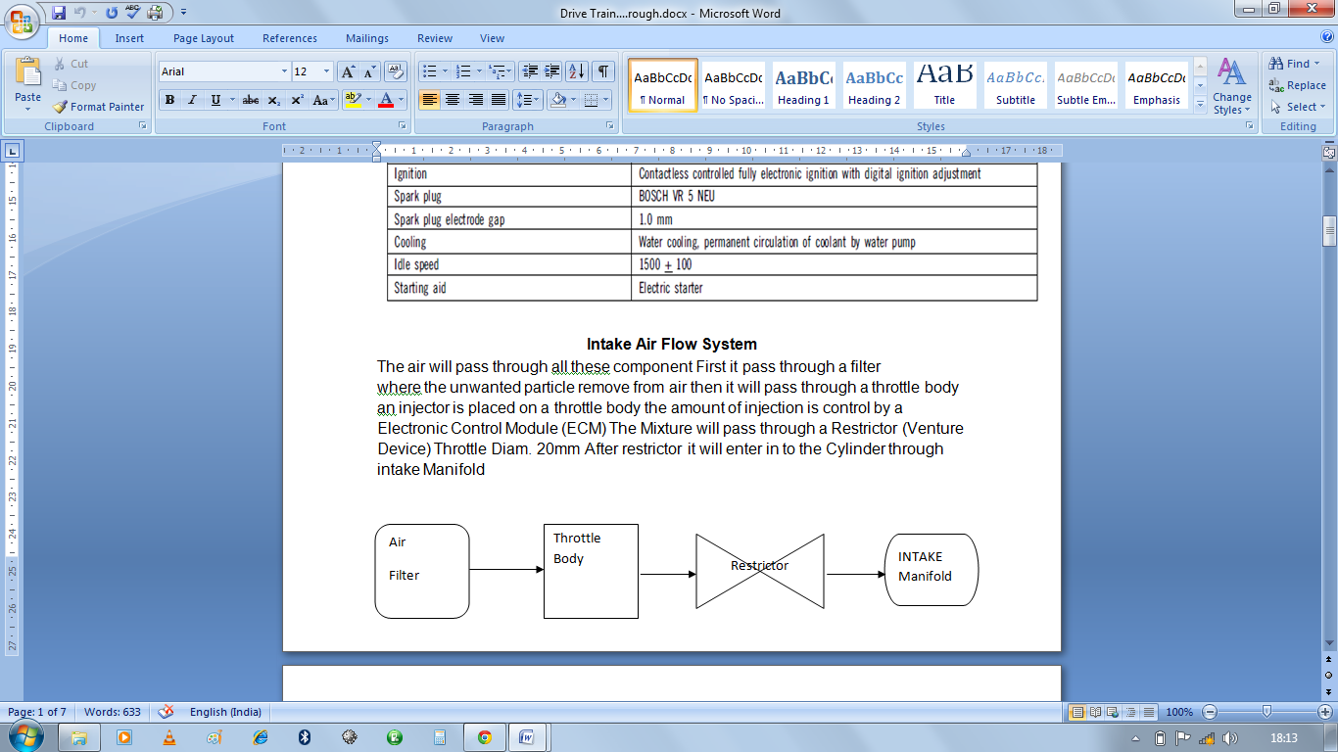

Figure No. 2 Air flow system

**Restrictor Basic Design and Manufacturing Process**

The restrictor is only part manufactured by the team the size and dimension are by rulebook and by considering engine intake pipe diameter,

First we select a material of venturi- aluminum

Manufacturing Machine -lathe

Normal length - 6"

Bigger diameter -40mm and smaller diameter is 20mm

The total Expenditure on venturi is 450rs

**Venturi Analysis Report**

Analysis boundary conditions-

Outlet pressure- 1.01325*105 Pascal

Velocity inlet- 33.33 m/s

Fluid- air only

Throat dia.- 20 mm

Convergent and divergent section dia.- 40 mm

Throat length- 1 cm (FIXED IN ALL)

Divergence length- 5 cm (FIXED IN ALL)

Software didn’t need material constraint for this analysis. So the consideration of stainless steel or fibre didn’t mattered a lot. This is due to the fact that the creo model is created as **extrude as surface** (not extrude as solid) and it didn’t asked thickness.

**(RESULT CONTOUR)**

The pressure contour is **pressure at inlet** and velocity contour is **velocity at outlet**.

Flow separation takes place in every venturi in divergent section (as gradual divergence is to be given in venturi and we have taken a fixed divergence of 5 cm in all venturis)

CONCLUSION- As per observation the venturi with 6inch overall length is suited best as pressure drop is minimum with respect to other and flow separation is also minimum in it.

**After final approval of venturi length the fuel flow can also be utilized in the analysis.**

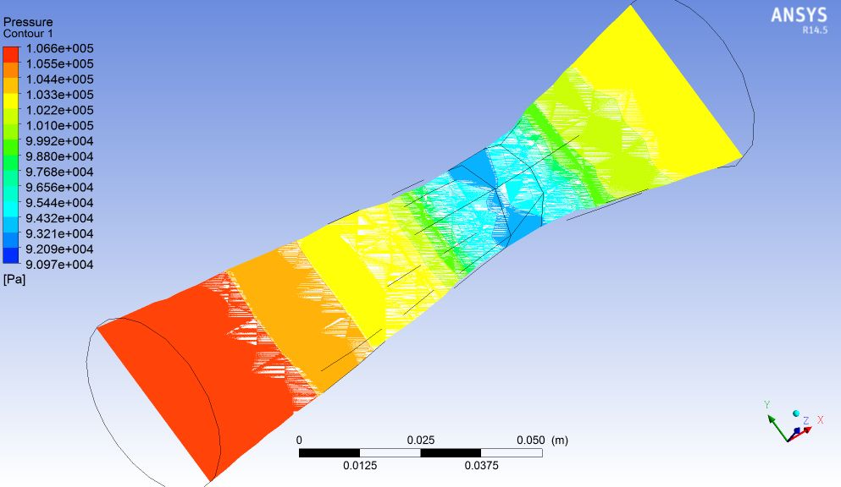

Figure No. 3

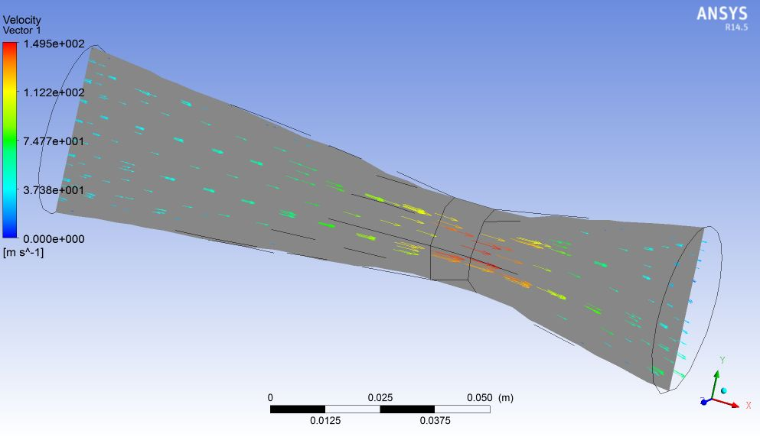

Figure No. 4

**Radiator analysis:**

Tube specifications:

Inner diameter- 8 mm

Material- Copper

Solver- ANSYS FLUENT

Solver Specifications-

Type - pressure based

Velocity formulation - absolute

Time- steady

Viscous model- k-epsilon

K-epsilon model- RNG

Near wall treatment- Enhanced wall treatment

Analysis Boundary Conditions-

Mass flow rate at inlet- 0.025 kg/s

Outlet pressure- 1.01325*105 Pascal

**Solution Methods-**

Pressure-Velocity Coupling Scheme- simple

Spatial Dis creatization

Gradient- Least Square cell based

Pressure- Standard and second order

Momentum- First order upwind and second order upwind

Turbulent Kinetic Energy- First order upwind and second order upwind

Turbulent Dissipation Rate- First order upwind and second order upwind

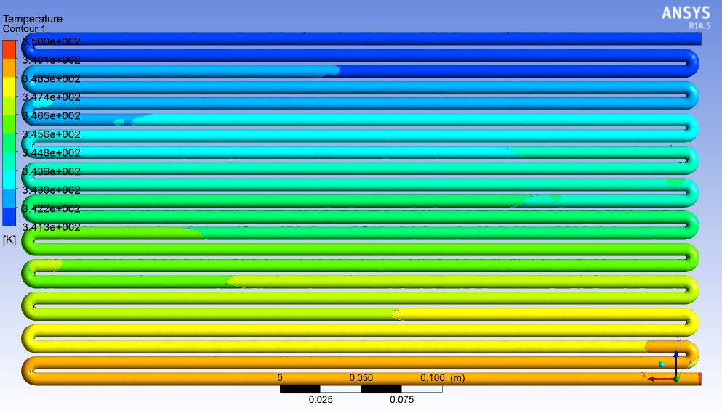

Figure No. 5 Temperature drop within the bare radiator tubes

**Drive Train Assembly**

The weight of vehicle is 300 kg and the weight of a bike is a 190kg hence there are more losses. The Transmission line flow is from engine sprocket to differential sprocket from differential it will pass to the wheel by Drive shaft and through Cv-joints so there are more speed reduction.

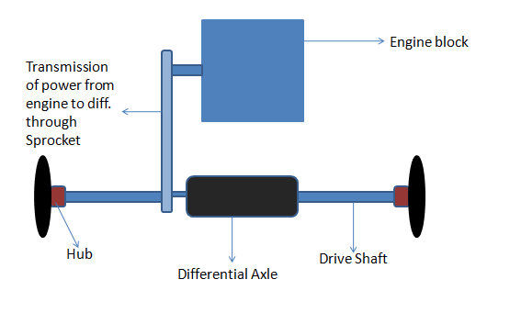

Figure No. 6 Drive train assembly

**Power Transmission Flow**

**Transmission:-**

* + Type- Manual
  + Clutch in oil bath/mechanically activated-8 plates
  + 6 speed constant mesh
  + Differential type- Straight Bevel Gear
  + Final drive ratio- 6.72

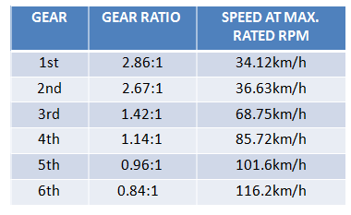

Figure No. 7 Calculated ratios

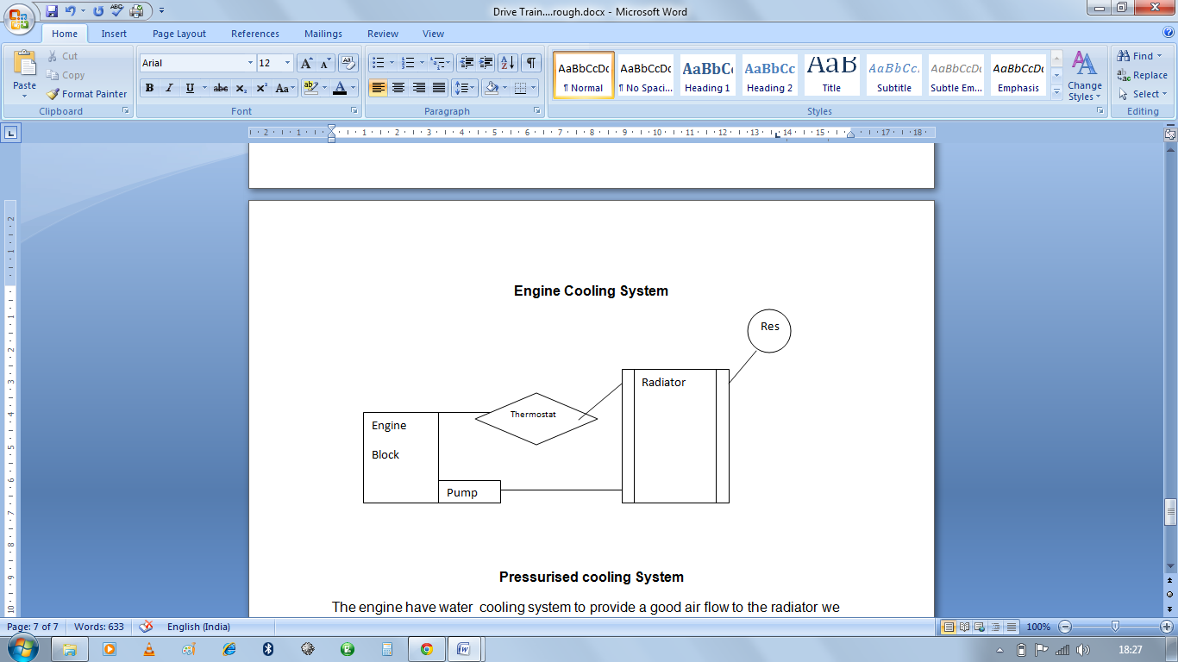

Figure No. 8 Engine Cooling System

**Pressurized cooling System**

The engine have water cooling system to provide a good air flow to the radiator we change the position of radiator by extending the hoses of radiator we are providing a duct to give a proper flow of air to the radiator

We have a done a thermal analysis of radiator and computational fluid dynamics of duct.

**Differential mounting analysis**

Material- Steel

Load-1700N

FOS-50

Deflection-1.966e-3mm

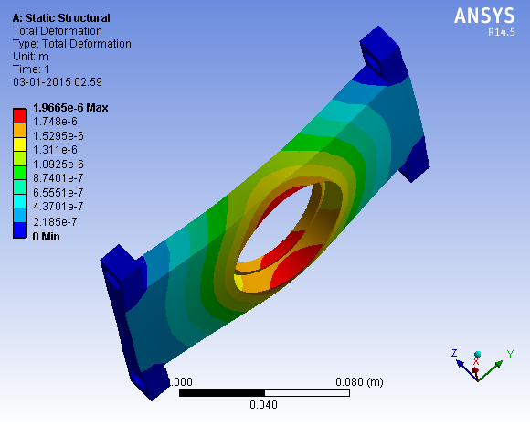

Figure No.9. Deformation in differential mounting

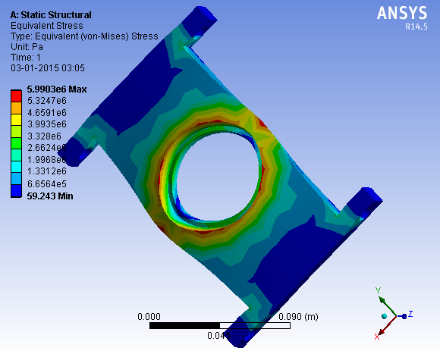

Figure No10. Stresses in differential mounting

Conclusion

Design of venturi shows that reducing intake manifold area don’t bother engine air flow requirement, which is 1/5th of the available flow of the venture. Using only bare copper tubes in the radiator the temperature drop approximately by 100C, which when used with fin area of 1.2 m2(approx.) will serve radiator’s purpose using proper ventilation by duct.

eLECTRICAL AND ELECTRONICS

MAIN SECTION

Different switches are

* Master switch
  + Primary master switch
  + Cockpit mounted master switch
* Brake over travel switch

**Important considerations**

* To focus on complex wire problems we are installing harnesses so as to simplify the wires coming out from different circuits.
* Setting up proper position of both the batteries used in the car which will help simplifying the circuit.

**Batteries**

We have used two batteries in our car

* Dry cell (500 MA, 12V)
* Dry cell (32A, 12V)

**INNOVATION IN CAR**

Rear Car detector circuit:-

* We are using an object detector circuit to locate the position of the nearby car and to detect the car which is on the verge of overtaking us.
* We will be using IR transmitter and Photo diode to detect other vehicles.

**ACTUAL CIRCUIT DIAGRAM**

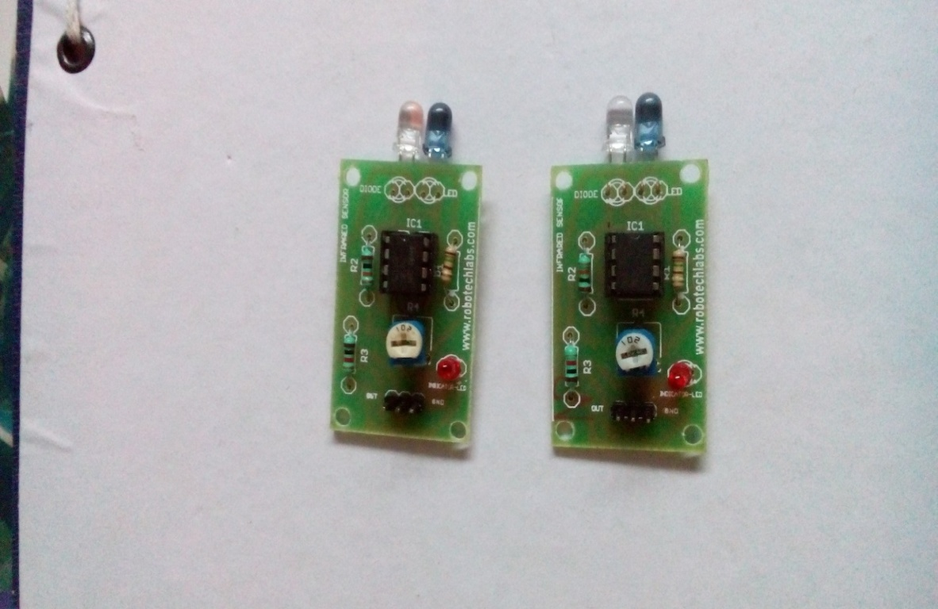

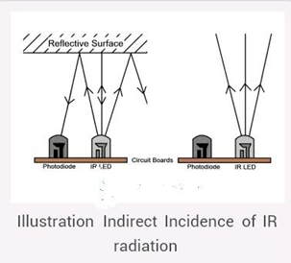

**Specifications:**

* The range of circuit 1.2m
* Leds will indicate the position of the car near our vehicle
* Dry cell battery of 12 volts, 500 mA will be used to run the circuit.

Acknowledgments

The authors would like to thank Prof. R. U. Patil, Prof. S. S. Naidu, Prof. B. C. Bissa and the rest of the IMPULSIFIERS and alumni for the support and advice during this project.

References

<http://suprasaeindia.org/>

<http://suprasaeindia.org/download.html>

<http://robomart.com>

<http://suprasaeindia.org/discussion-forum.html>